A r t B e a t 2 0 2 0
C R A F T V E N D O R A P P L I C A T I O N

Saturday, July 11th in Davis Square, Somerville MA
(Rain Date: Sunday July 12th)

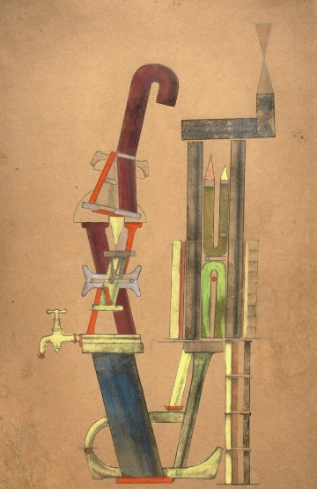
ArtBeat is Somerville's annual multi-media street party! The festival showcases the City's diverse and vibrant arts communities and attracts ten thousand visitors to Davis Square. Presented by the Somerville Arts Council (SAC) and Mayor Joseph A. Curtatone. ArtBeat is now its 34th year and features an eclectic mix of music, dance, theater, food, performance and interactive activities.

More than 80 regional and local craft and fine art vendors, who create their own work, will be chosen to present for 7 hours on Saturday afternoon. “Chance” is a celebration of all things unexpected, unplanned, fluky and fortuitous. We invite artists and community members to interpret this theme in a variety of ways. “Chance” conjures many things: games, gambles, chance encounters and dada, an early 20th-century art movement that celebrated chance as opposed to reason or logic. Let’s take a chance at ArtBeat this year and explore how things happen when we don’t follow detailed plans and instead embrace serendipity.

Perhaps artists will create dada-inspired public artworks or interactive games involving chance, or dancers might explore movement that responds to an element of chance—like a surprise shift in music. Comedians might plan an improv workshop and storytellers might explore themes of unexpected outcomes. We look forward to your creative interpretation of this theme!

Application Deadline: Tuesday, March 31st
A R T B E A T 2 0 2 0 C R A F T V E N D O R A P P L I C A T I O N

Guidelines: Please read carefully and keep this page for future reference.
Note that quality and presentation of materials is important

WHO SHOULD APPLY

To support the creative efforts of local artists and artisans, all work must be designed and/or handcrafted by the applicant. NO IMPORTS, MANUFACTURED ITEMS, resale items or kits will be accepted.

Craft vendors may share booths. However, applicants must prepare separate applications and email them individually. Both/all applicants must be accepted in order to share a booth.

HOW TO APPLY

Support materials for ArtBeat craft application will be submitted online via the Somerville Arts Council Google Drive and sent to: somartscalls@gmail.com
Below, you will find a description for the application process.

- Please review the Google Drive instructions below.
- In the header of your submission, please use the following information: (Your Last Name)-(Your First Name)- ArtBeatCraft2020-(Category of Entry). For example: “Epstein-Michael- ArtBeat2020-Jewelry”
- You will submit a folder that will include the following items: 5 color jpegs (1 MB max) of current work representing the type(s) of work you will show and the completed application form (please upload final as PDF).
- First-time artisans must include résumé and recent juried show history & photo of your booth

IMPORTANT DATES & RULES:

All applications must be emailed by Tuesday, March 31st to the Somerville Arts Council. The craft jury will evaluate applications in terms of quality, originality, and marketability.

PLEASE NOTE & READ: Past participation at ArtBeat does not guarantee an acceptance for this year. Applications without visual support materials (jpegs or URLs), and incomplete information will be disqualified. All notification e-mails will be sent by the end of April/early May. Accepted applicants will receive preliminary details along with an agreement letter that must be filled out, signed, and returned to the Somerville Arts Council with their enclosed vendor payment.

Complete packet with set-up information, directions, etc. will be mailed in late June/early July.

Application Deadline: Tuesday, March 31st

Instructions for submitting support materials via Google Drive
If you have an existing Google Drive or Gmail account, skip to #2.

- If you do not have a Google Drive account go to: http://drive.google.com
In upper right-hand corner, click on “Sign Up” and follow prompts. (You do NOT need to create a “new” Gmail email; you can use an existing email address and still create a Google account to use Google Drive)

Once you have a Google Drive account:

- Go to: http://drive.google.com
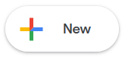
- In the upper left, click the A drop-down menu will appear. Select the folder option.
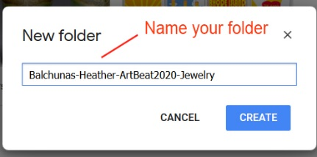
- A “new folder” dialog box will pop up asking for a name. Type the name in the following format:
(Your Last Name)-(Your First Name)- ArtBeatCraft2020-(Category of Entry) For example: “Balchunas-Heather- ArtBeat2020-Jewelry” Press create

- Click on the folder name you have just created, listed at the top
of your documents list.

- You should see “My Drive->(Your Last Name)-(Your First Name)- ArtBeat2020-(Category of Entry)” listed at the top of the page with a blank space below. Drag or upload ALL submission materials into this folder (ArtBeat application, CV, jpegs, etc.). You should convert Word Documents into PDFs, to both secure your information and for staff and panelists to view easily. Reconfirm what you need to include, refer to the section in the guidelines that is called “Filling out the Application.”

- Alternatively, while on this screen, you may click the red arrow pointing up, next to the create button and select “files” to upload files. A dialog will pop up and you may select the files you wish to upload.

- One you see all of the files you wish to submit included in your folder, you are ready to submit.

- As with all current technology, depending on your computer make (PC vs. Mac) and your internet browser, the next step with Google Drive is not consistent. With PCs and Internet Explore you should see a checkbox to the left of your folder. Check this, then either right click your mouse or click on the drop down and you should see a “Share” icon. Click on this and a dialogue box will appear. A window called “sharing settings” should appear. In this window, there is a box that says “invite people” - click on this box and type in:
somartscalls@gmail.com

Make sure “can edit” is selected in the box on the right and the box for “notify people via email” is checked. Press the green “Share and Save” button and then press the blue “done” button.

Your materials have now been submitted.

Additional note: if at any time, you lose your place or cannot find your folder, simply reopen your browser, go to the URL: http://drive.google.com and your folder should appear. Always be sure to click on the folder name first before adding materials. You should always be adding materials from the screen that has “My Drive->(Your Last Name)-(Your First Name)-ArtBeatCraft2020-(Category of Entry)” listed at the top of the page.

A R T B E A T 2 0 2 0 C R A F T V E N D O R A P P L I C A T I O N

Applicant Name

Business Name

Address

City/State/Zip

Phone (day) (evening)

Email

Craft category: ___ jewelry ___ apparel /textile __ photography ___prints ____ paintings/drawings
_____ceramics _______other
Price Range: $ ____ to $_________ Have you ever been an ArtBeat vendor before?
If so, what years? __15 __16 __17 __ 18 __19
Will you be sharing a booth? _____Yes ______No If yes, with who? _______________________________
*First time applicants only: Briefly, on a separate piece of paper, tell us about your training and craft show history or include a resume, if that's easier.
Please provide a description of the work you will sell at ArtBeat:

Please provide a description of your booth set up.

Image list and description

Submit 5 color jpegs representing your current work you will be exhibiting. Please review instructions above. Below, label each image with your last name followed by a number such as "leeman01". Give corresponding information; include dimensions, materials and prices. IMPORTANT NOTE: Previous ArtBeat participation does not guarantee placement. Vendors are selected on the quality and strength of the applications materials. Shared spaces/applications are juried separately.
1.
2.
3.
4.
Application Deadline: Tuesday, March 31st
5.

